**MULTISENSORY FUSION FOR UNDERWATER ROBOT LOCALIZATION AND EXPLORATION**

**BY**

**UMAIR ALI**

**18001222019**

**MS Electrical Engineering**

**Department of Electrical Engineering**



**UNIVERSITY OF GUJRAT**

**Session 2018-2020**

**UMAIR ALI M.Sc Electrical Engineering 2018-20**

**MULTISENSORY FUSION FOR UNDERWATER ROBOT LOCALIZATION AND EXPLORATION**

**A Thesis Submitted in Partial Fulfillment of the Requirements for the Award of Degree of**

**MS**

**In**

**Electrical Engineering**

**BY**

**UMAIR ALI**

**18001222019**

**Department of Electrical Engineering**



**UNIVERSITY OF GUJRAT**

**Session 2018-20**

**ACKNOWLEDGEMENT**

I would like to thank Allah Almighty who blessed me with a very motivating and kind supervisor, Dr. Muhammad Wasif who has been always available to help me wherever I faced any difficulty. He always provided me a challenging environment so I could build up an ability to learn something new. I cannot forget his patience, availability, and supportive nature so I could complete my thesis in time.

**(Umair Ali)**

**DEDICATION**

Dedicated to my parents who supported me to fulfill my dreams.

**(Umair Ali)**

**DECLARATION**

I Umair Ali S/O Muhammad Sajjad Haider, roll # 18016522-008, MS Electrical Engineering scholar, Department of Electrical Engineering, Faculty of Engineering & Technology, University of Gujrat, Pakistan, hereby solemnly declare that this thesis titled “Multisensory Fusion for Underwater Robot Localization and Exploration” is based on genuine work, and has not yet been submitted or published elsewhere. I Furthermore, I shall not use this thesis for obtaining any other degree from this university or any other institution.

I also understand that if evidence of plagiarism is provided in my thesis at any stage, even after the award of the degree, the degree may be cancelled and revoked by the University authority.

**(Umair Ali)**

It is certified that Umair Ali S/O Muhammad Sajjad Haider, roll # 18016522-008, M.Sc Electrical Engineering scholar, Department of Electrical Engineering, Faculty of Engineering & Technology, University of Gujrat, Pakistan, worked under my supervision and the above stated declaration is true to the best of my knowledge.

**_____________________**

Dr. Syed Muhammad Wasif

Assistant Professor, Department of Electrical Engineering

University of Gujrat, Punjab, Pakistan.

Email: syed.wasif@uog.edu.pk

Dated:

**THESIS** **COMPLETION CERTIFICATE**

It is certified that this thesis titled “Multisensory Fusion for Underwater Robot Localization and Exploration” submitted by Umair Ali S/O Muhammad Sajjad Haider, roll # 18016522-008, MS Electrical Engineering scholar, Department of Electrical Engineering, Faculty of Engineering & Technology, University of Gujrat, Pakistan, is evaluated and acceptance for the award of the degree ”Master of Science (MS)” in Electrical Engineering by following members of the Thesis/ Dissection Viva Voce Examination Committee.

The evaluation report is available in the Directorate of Advance Studies and Research Board of University.

**_________________________**

Dr Atta Ur Rehman

Assistant Professor

Rachina College of Engineering & Technology, Jora Sian, Ghakkar, Gujranwala

Email: a.ur.rehman@uet.edu.pk

**_________________________**

Dr.Syed Muhammad Wasif

Assistant Professor, Department of Electrical Engineering

University of Gujrat, Punjab, Pakistan.

Email: syed.wasif@uog.edu.pk

**_________________________**

Dr.Shahid Iqbal

HOD, Department of Electrical Engineering

University of Gujrat, Punjab, Pakistan.

Email: si@uog.edu.pk

|  |  |
| --- | --- |
| **TABLE OF CONTENTS** | |
| **CONTENTS** | **PAGE** |
| LIST OF FIGURES…………………………………………………………….. | **vi** |
| LIST OF TABLES………………………………………………………… | **vii** |
| LIST OF APPENDICES………………………………………………….. | **viii** |
| ABSTRACT……………………………………………………………….. | **01** |
| CHAPTER 01: INTRODUCTION……………………………………….. | **02** |
| 1.1: Problem Statement…………………………………………… | **05** |
| 1.2: Objectives and Scope of Study...………………..…………. | **05** |
| CHAPTER 02: LITERATURE REVIEW……………………………….. | **06** |
| 2.1: Navigation Systems for Underwater Localization….…………. | **06** |
| 2.1.1: Inertial or Motion Sensors…………………...…………. | **06** |
| 2.1.2: Acoustic Positioning Systems………………….……….. | **08** |
| 2.1.3: SONAR and Vision-based Localization Systems…….. | **09** |
| 2.2: Fusion Algorithms for Underwater Localization……………… | **11** |
| 2.2.1: Kalman Filter…………………………………………….. | **11** |
| 2.2.2: Extended Kalman Filter………………………………….. | **12** |
| 2.2.3: Unscented Kalman Filter………………………………… | **13** |
| 2.2.4: Particle Filter…………………………………………….. | **14** |
| 2.2.5: Machine Learning Methods……………………………… | **15** |
| 2.2.6: Bio-inspired Approaches………………………………… | **16** |
| CHAPTER 03: RESEARCH METHODOLOGY……………………….. | **17** |
| 3.1: PC/BC-DIM Neural Network…………………………………... | **17** |
| 3.1.1: Training of Weights……………………………………………. | **20** |
| 3.1.2: Multisensory Data Fusion……………………………………… | **20** |
| 3.2: PC/BC-DIM Neural Network for UW Localization…………... | **22** |
| 3.2.1: Sensors for Simulations………………………………………... | **22** |
| 3.2.2: Encoding of Sensors………………………………….………… | **23** |
| 3.2.3: Decoding of Reconstructed Input…………………………….. | **23** |
| 3.3: Algorithm of PC/BC-DIM for Underwater Localization …………… | **24** |
| CHAPTER 04: RESULTS AND DISCUSSIONS………………………. | **26** |
| 4.1: Demonstration of PC/BC-DIM Result………………………………… | **26** |
| 4.1.1: Random Noise Addition………………………………………. | **26** |
| 4.1.2: Non-Gaussian or Abrupt Noise Addition……………………… | **28** |
| 4.2: Simulation Data Comparison with a B-PR-F Neural Network………. | **28** |
| 4.2.1: PC/BC-DIM and B-PR-F Comparison………………………… | **29** |
| 4.2.2: All Sensors B-PR-F and without IMU PC/BC-DIM Comparison………………………………………………….…. | **32** |
| 4.2.3: All Sensors B-PR-F and without DVL PC/BC-DIM Comparison…………………………………………………….. | **33** |
| 4.3: Experimental Data Comparison with a B-PR-F Neural Network……... | **33** |
| CHAPTER 05: CONCLUSION AND DISCUSSIONS…………………. | **37** |
|  |  |

|  |  |  |  |
| --- | --- | --- | --- |
| **LIST OF FIGURES** | | | |
| **CONTENTS** | | **PAGE** | |
| Figure-1.1: Connectivity of different sensors for underwater localization………………………………………………….. | | **02** | |
| Figure-1.2: General idea of multisensory fusion ………………………. | | **04** | |
| Figure-2.1: Working principle and geometry of DVL system…………. | | **07** | |
| Figure-2.2: Types and geometry of acoustic positioning system……… | | **08** | |
| Figure-2.3: Visual localization approaches…………………………….. | | **10** | |
| Figure-2.4: Working principle of kalman filter………………………… | | **11** | |
| Figure-2.5: Typical extended kalman filter scheme……………………. | | **12** | |
| Figure-2.6: Comparison of unscented transform (UT) and EKF………. | | **14** | |
| Figure-3.1: PC/BC-DIM processing stages……………………………… | | **18** | |
| Figure-3.2: PC/BC-DIM noisy input reconstruction…………………… | | **19** | |
| Figure-3.3: PC/BC-DIM working principle…………………………….. | | **20** | |
| Figure-3.4: Trained weights of multiple sensors……………………….. | | **21** | |
| Figure-3.5: Fusion of two types of sensory inputs..……………………. | | **21** | |
| Figure-3.6: Encoding of sensory data…………………………………… | | **23** | |
| Figure-4.1: PC/BC-DIM outcome for noisy positioning points……….. | | **27** | |
| Figure-4.2: PC/BC-DIM outcome for 2 times noisy positioning points…………………………………………………………. | | **27** | |
| Figure-4.3: PC/BC-DIM outcome for non-gaussian or abrupt noise….. | | **28** | |
| Figure-4.4: B-PR-F neural network results……………………………… | | **29** | |
| Figure-4.5: PC/BC-DIM neural network results………..………………. | | **30** | |
| Figure-4.6: Error comparison for both neural networks……………….. | | **31** | |
| Figure-4.7: Depth coordinate of B-PR-F neural network……………… | | **31** | |
| Figure-4.8: Depth coordinate of PC/BC-DIM neural network………… | | **32** | |
| Figure-4.9: Noisy USBL vs PC/BC-DIM results for depth coordinate.. | | **32** | |
| Figure-4.10: B-PR-F position estimation……………………………….. | | **35** | |
| Figure-4.11: PC/BC-DIM position estimation…………………………. | | **35** | |
|  |  | |

|  |  |  |  |
| --- | --- | --- | --- |
| **LIST OF TABLES** | | | |
| **CONTENTS** | | **PAGE** | |
| Table-2.1: Comparison of Conventional State Estimators for UWL…. | **15** | |
| Table-4.1: PC/BC-DIM and B-PR-F Simulation Comparison……………….. | **30** | |
| Table-4.2: PC/BC-DIM and B-PR-F Simulations without IMU…….... | **33** | |
| Table-4.3: PC/BC-DIM and B-PR-F Simulations without DVL……… | **33** | |
| Table-4.4: PC/BC-DIM and B-PR-F Experiment………………………. | **34** | |
|  |  | |

|  |  |
| --- | --- |
| **LIST OF APPENDICES** | |
| **CONTENTS** | **PAGE** |
| APPENDIX-01: Abbreviation Used in the Thesis…………………….. | **45** |
| APPENDIX-02: Turnitin Originality Report…………………………… | **46** |
|  |  |

**ABSTRACT**

Water covers more than 70 percent of the earth and most of the underwater area has not yet discovered. For underwater exploration and unusual activity inspection, Unmanned underwater vehicles (UAVs) are used which have lesser cost and no life risks as compared to manned underwater vehicles. line (USBL) values. Experimental results have 1.3526 roots mean square error and 1.0412 standard deviation error for the complete trajectory of 693 meters. The proposed Perdictive Coding Biased Competition Decisive Input Modulation (PC/BC-DIM) neural network can measure the position of an underwater robot more accurately and it can eliminate the highly abrupt noise of the USBL sensor.

# CHAPTER- 1

## INTRODUCTION

Pakistan has nearly 1000 kilometer long coast from Sir Creek to Jiwani and according to Law of the sea, the coastal countries are allowed up to 200 nautical miles of economic control from its territorial sea baseline. Self-localization plays an important role in the control and monitoring of an underwater robot as well as in search and rescue operations.

**Figure-1.1: Connectivity of different sensors for underwater localization**

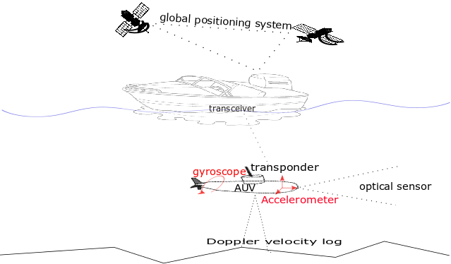

Figure 1.1 is showing the connectivity between different types of sensors which are used for underwater localization, with the help of dotted lines. The ship is connected to Global Positioning System (GPS) and AUV is connected to the transceiver of a ship through the acoustic transponder. sensors are combined for speed estimation and heading correction, respectively. One major limitation for underwater localization is the unavailability of GPS (Leonard & Bahr, 2016) and other electromagnetic signal-based positioning systems e.g., cellular networks and Wi-Fi positioning systems, etc. The salty conductive nature of the sea is highly impure for

**Figure-1.2: General idea of multisensory fusion**

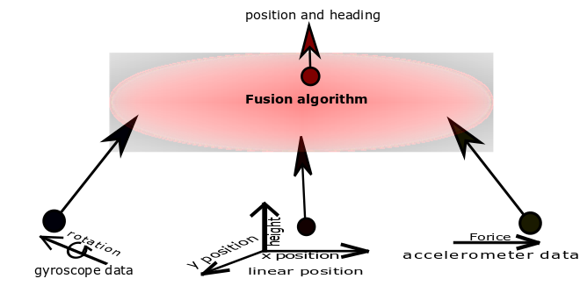

Figure 1.2 is presenting an idea to collect the data from different sensory modalities and to fuse that data of multiple sensors using a fusion algorithm to find the current position and heading of the object.

### 1.1: Problem Statement

The collection of exploration data in an unknown environment is meaningless when there is no known frame of reference. In the middle of the ocean, there is always ambiguity for estimation instead of a single sensor for localization in an underwater environment. Conventional fusion policies such as the Kalman filter can not model highly non-linear noise of the underwater environment. Multimodal hypothesis based techniques such as Monte-Carlo localization have high computational cost even in the presence of reliable sensory data. An optimal fusion policy for an underwater robot localization is required for the dynamic and unstructured nature of the seabed environment.

### 1.2: Objectives and Scope of Study

The main objective of the thesis are

To investigate available technologies and techniques of underwater localization.

* To examine state estimators and their limitations for underwater multisensory fusion.
* To analyze recent developments for underwater localization
* To develop an efficient and accurate fusion policy for optimal location estimation in a dynamic and unstructured underwater environment.

# **CHAPTER– 2**

## **LITERATURE REVIEW**

In this chapter, a very basic to advance level review is presented. Autonomous Underwater technologies and fusion algorithms with their specifications are discussed below.

**2.1: Navigation Systems for Underwater Localization**

Navigation systems are divided into three main categories for underwater vehicle localization: used in various projects.

**2.1.1: Inertial or Motion Sensors**

Most of A…….diagram of the DVL sensor is shown in figure 2.1 by (Vasilijevic, Borovic, & Vukic, 2012).

**Figure-2.1: Working principle and geometry of DVL system**

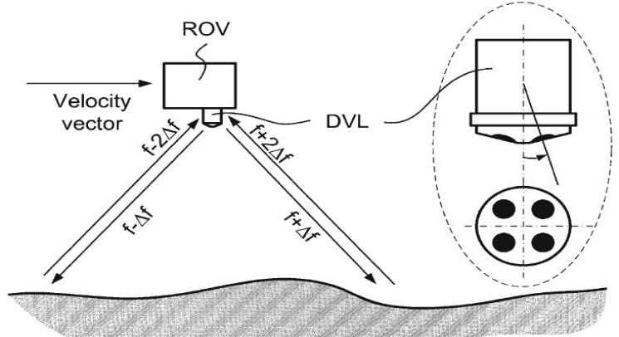

(Vasilijevic et al., 2012)

Figure 2.1 represents the working principle and shape of the DVL system which produces a velocity vector. DVL is placed at the bottom of an underwater robot. It triggers and receives the back-scattered acoustic signals to estimate the current velocity of an underwater robot. (J. Zhang et al., 2014) IMU is used for 3D location estimation of a robotic fish when the sampling rate is used as 50 Hz. DVL cannot be affected by gravity and pressure so acoustic sensors are the better choice for deep underwater odometry or velocity estimation.

**2.1.2: Acoustic Positioning Systems**

Over time, dead reckoning based sensors accumulate the residual error and this does not … of acoustic positioning systems

* Long baseline (LBL)
* Short baseline (SBL)
* Ultra-short baseline (USBL)

**Figure-2.2: Types and geometry of acoustic positioning system**

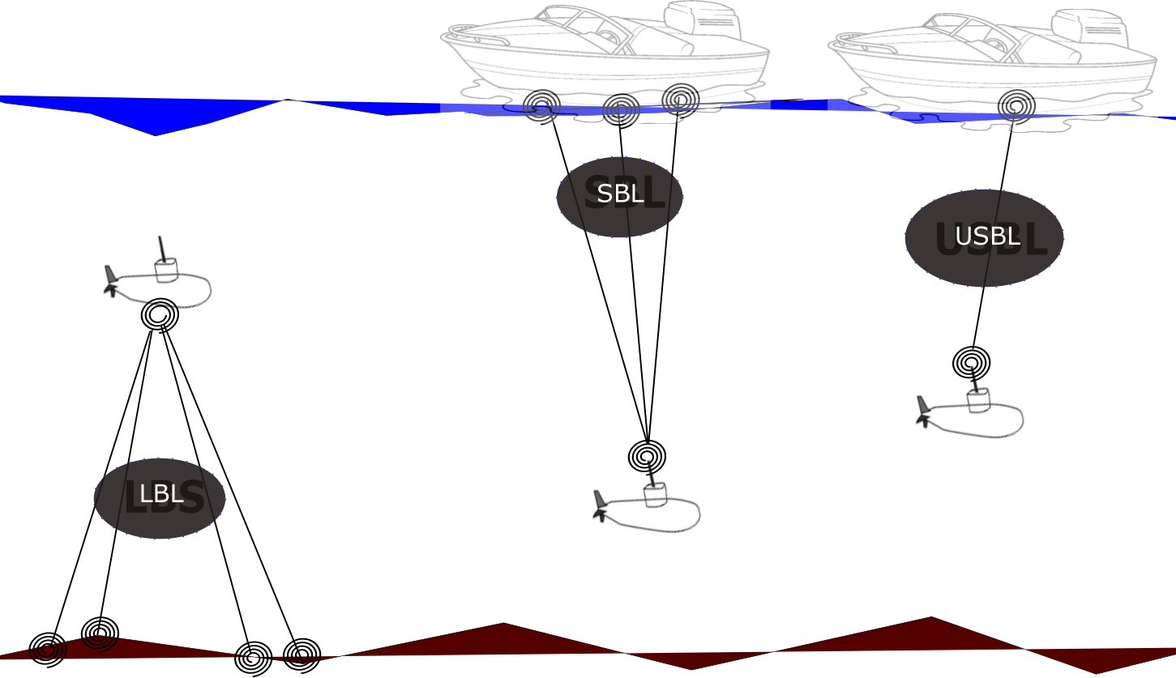

Figure 2.2 presents acoustic sensors and their geometry. LBL are fixed nodes and covers a large area for underwater robot localization. SBL uses onboard multiple transducers and one transponder. USBL uses one transducer and one transponder only and has a smaller acoustic ranging as compared to SBL and LBL.

In literature, all of these sensors have been used for various purposes. Long baseline acoustic posi----- ons for underwater communication while USBL is used as a stand-alone position estimating system.

LBL is-----ation delay affects the accuracy of the vehicle by the addition of non-gaussian noise in USBL as well.

(Caiti et al., 2014) proposed a mixed LBL and USBL system for underwater location estimation. In the experiment, LBL is used as fixed nodes with the help of moored modems while a US--------acoustic position systems in an underwater environment. The magnetic induction technique is not mature enough and is not directly applicable due to the directional communication and salty conductive nature of seawater temper conductivity.

**2.1.3: SONAR and Vision-based Localization Systems**

In vision-based localization, the very first task is the recognition of the objects. In some recent advanceme----------underwater localization. Camera estimates location with the delay of recognition and it is also dependent on known objects for reference. Low cast pressure sensors and IMU are integrated with a camera to make a monocular odometry for underwater vehicles (Creuze, 2017) for pose estimation. Similarly, (Ferrera, Moras, Trouve-Peloux, & Creuze, 2019) proposed a visual odometry algorithm that is tested on different noisy images.

**Figure-2.3: Visual localization approaches**

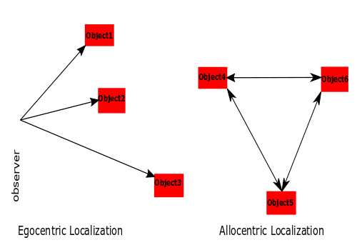

Figure 2.3 is representing the egocentric and allocentric localization concept. Robot location can be estimated online using imaging sonar which gives better position measurements than dead reckoning using DVL and gyroscope (Johannsson, Kaess, Englot, Hover, & Leonard, 2010). A SLAM with itee for localization.

**2.2: Fusion Algorithms for Underwater Localization**

For underwater localization using multi-sensor fusion (MSF), various methods are discussed in (Pan & Wu, 2016) (Tan et al., 2011) (Leonard & Bahr, 2016) (Paull et al., 2013).

**2.2.1: Kalman Filter**

Kalman Filter (KF) is a stochastic filtering based state estimating algorithm that comprises prediction and estimation stages.

**Figure-2.4: Working principle of kalman filter**

Figure 2.4 is showing the general working of the Kalman filter in which the filter gives the hypothesis of location by combe output of the Kalman filter.

**2.2.2: Extended Kalman Filter**

The Extended Kalman Filter (EKF) is used for converting the non-linear system to a locally linear system by involving underwater environment noise covariance matrix is difficult to obtain and a constant covariance matrix can not be used for dynamic scenarios.

**Figure-2.5: Typical extended kalman filter scheme**

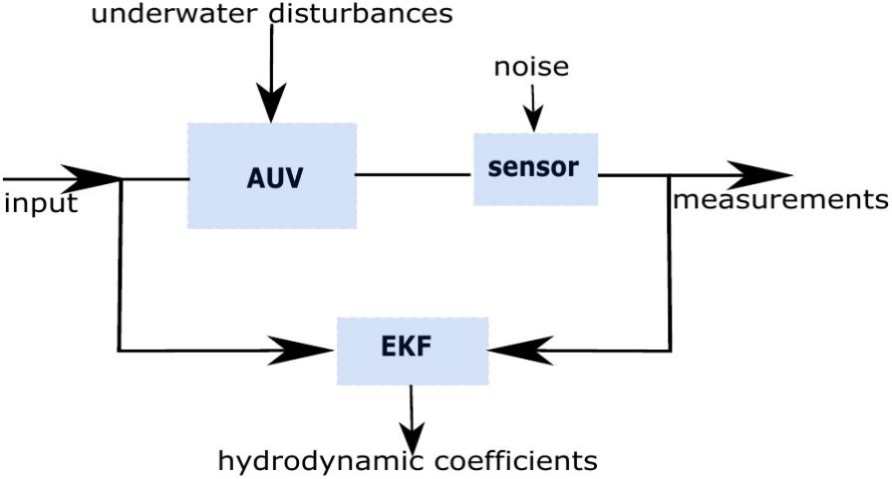

An adaptive EKF is proposed for dynamic covariance matrices in (Shao, He, Guo, & Yan, 2016) considering prior ------------V is simulated for underwater localization in Matlab software in which main sensor IMU and auxiliary sensor DVL are used for motion estimation.

In (Tal, Klein, & Katz, 2017), Tal has integrated the accelerometer and gyroscope data into an inertial system which is further corrected by auxiliary sensors to feed to an EKF. EKF accurately able to find the next …………….error bounded in range of 0 to 1.7 m for 270 m trajectory. EKF is used in (Guerrero-Font, 2016) for collecting continuous odometry data and USBL to get reliable position estimation

**2.2.3: Unscented Kalman Filter**

Unscented Kalman filter (UKF) does better approximation than EKF because it considers true deviation points and does transformation ,,,,,,han EKF. Figure 2.6 is showing the convergence of UKF and EKF which briefly describe the convergence attitude of EKF and UKF. Accuracy of UKF is better than EKF but with more sigma points the computational cost of UKF increases.

To achieve the best possible accuracy research proposed various schemes. In (W. Li, Wang, Lu, & Wu, 2013) a novel scheme is proposed in which DVL and strap-down inertial navigation system (SINS) are deployed and alignment adaptive UKF is used. UKF working is similar to a KF as both filters predict the me

**2.2.4: Particle Filter**

In literature for underwater localization,………f two stages as the usual Bayes filters. The first stage predicts the location of an underwater robot using onboard sensory data such as IMU, DVL, etc. The second stage corrects the predicted location using external information such as USBL and DGPS. The results in (Kim, 2011) show that it is possible to estimate the robot location in 3D space using only two acoustic beacons.

**Figure-2.6: Comparison of unscented transform (UT) and EKF**

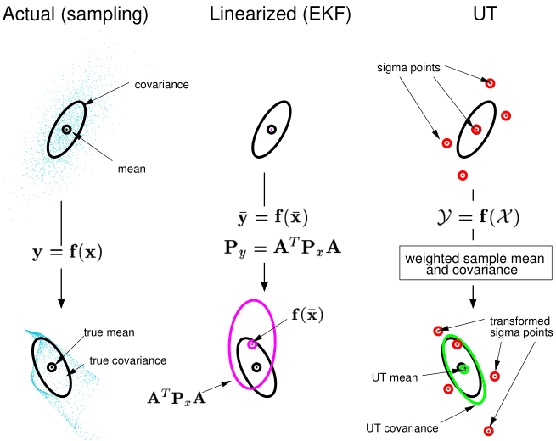

(Wan & VanDer Merwe, 2000)

In (Mandic, Renduli c, Mi skovi c, & Na, 2016), the OWTT-iUSBL system uses a known waveform which is triggered ……..UV Virtual and real environment. The proposed technique is capable of running online and represent the environment more accurately.

|  |  |  |  |  |
| --- | --- | --- | --- | --- |
| Table-2.1: Comparison of Conventional State Estimators for UWL | | | | |
| **Filter** | **Working principle** | **Model** | **Computational cost** | **Distribution** |
| KF | Unimodel hypothesis | Linear | Low | Gaussian |
| EKF | Taylor series expansion | Locally linear | Low - medium | Gaussian |
| UKF | Sigma point distribution | Non-linear | Medium | Gaussian |
| PF | Multi-model hypothesis | Non-linear | High | Non-Gaussian |
|  | | | | |

Table 2.1 describelti-model hypothesis but it has a high computational cost.

**2.2.5: Machine Learning Methods**

Machine learning methods are preferred to deal with highly non-linear systems, nowadays. The main focus of researchers f………..ed a novel underwater localization scheme called B conditions remain almost similar between training and execution time. To identify the reliability of acocessing reasons. Time delaying estimation is made in (Houegnigan et al., 2017) where a neural network is used to estimate the possible delay of acoustic positioning sensor for more consistent results.

**2.2.6: Bio-inspired Approaches**

Some bio-inspired work is presented,,,,,,,efined map the location can be estimated (Muhammad, Toming, Tuhtan, Musall, & Kruusmaa, 2017). Similarly based on mammals n……nchronous comparison for underwater robot localization is presented in (Ko, 2016) where the simulations and experimental results are in statistics for a vehicle to travel from one point to another in 3D space.

Based on key info,,,,,,ween the robot and the landmark (Zhang, 2014). Odometry is generated for the robot based on the data of IMU. From the experimental results, it can be concluded that the proposed localization approach can localize the robotic fish quickly and accurately.

# CHAPTER- 3

## RESEARCH METHODOLOGY

The location of exploration data is meaningless without a reference of known location and the underwater environment ….ictive Coding Biased Competition Decisive Input Modulation (PC/BC-DIM) neural network and simulations are described in the sections below.

### 3.1: PC/BC-DIM Neural Network

PC/BC,,,,,,e up of three different neuron populations. The functioning of each neuron population is expressed in 3.1, 3.2 and 3.3 equation.

|  |  |  |
| --- | --- | --- |
|  |  | (3.1) |
|  |  | (3.2) |
|  |  | (3.3) |

where x, e and r are input vector, error and reconstruction neuron activation functions respectively having…..onse of prediction neurons. Prediction neurons activation (y) are initialized with small random values or with zero values. The PC/BC-DIM network iterates for a number of iterations to determine the stable response of each neuron population activation.

**Figure-3.1: PC/BC-DIM processing stages**

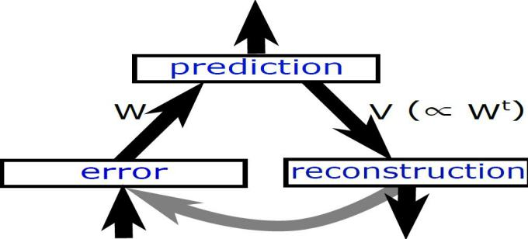

The input of PC/BC-DIM network is termed as causes that are encoded into useful information. Every new input plays a role in the training of weights. Adding up the same sensor input not only increases the size of weights but it also consumes more computation and makes the network process slow down. To overcome this situation, the proposed network can be trained on the explaining away pattern of reasoning in which the same sensor input is not required and only different information from weights is considered to update the weights. T………erges to the solution more slowly and a solution is less sparse furthermore subtractive method is less biologically plausible.

**Algorithm-3.1: ActivationPCBC(x,W)**

1: **for** i = 1:iterations

2: r = V*y

3: e = x ./ (e2 + r)

4: y=(e1+y).*(W*e)

5: **end**

PC/BC-DIM can perform computations with probability distributions when input is a probability function. Weights are the elementary components so every specific input can be reconstructed from these weights. PC/BC-DIM can reconstruct noiseless signals. Figure 3.2 shows that how a noisy causes reconstruction through the PC/BC-DIM neural network.

**Figure-3.2: PC/BC-DIM noisy input reconstruction**

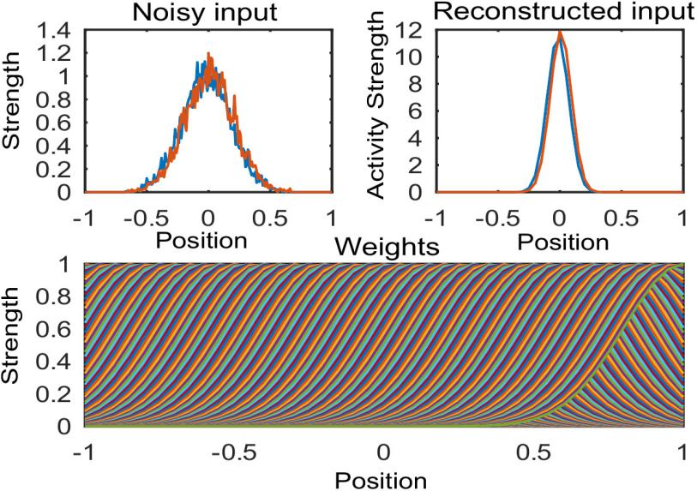

Sensory measurements of an underw,,,,,hts are considered as a modeled system that is … results are obtained using noisy sensory data. The input of sensors can be encoded in various formats and to encode them into probability density function one-dimensional gaussian equation is presented in equation 3.4 below.

|  |  |  |
| --- | --- | --- |
|  |  | (3.4) |

A single dimensional gaussian encoded input is used to set a weight vector in W weight matrix…….Reconstructed input can be decoded back with the help of following equation:

|  |  |  |
| --- | --- | --- |
|  |  | (3.5) |

where μ is th…….e variance can be calculated using the equation below

|  |  |  |
| --- | --- | --- |
|  |  | (3.6) |

The filter can combine the likeliho……he filter.

**Figure-3.3: PC/BC-DIM working principle**

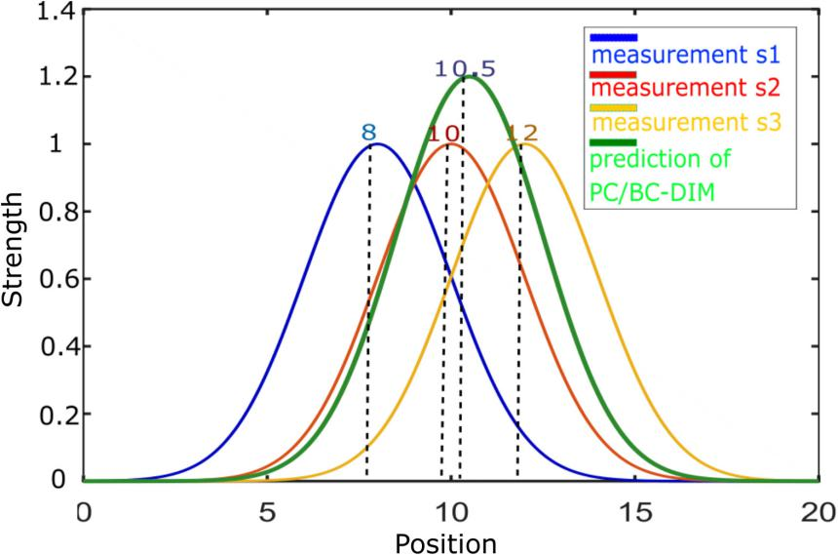

**3.1.1: Training of Weights**

In a neural …….. all weights are concatenated like all sensors and reconstructed input r is obtained.s

**3.1.2: Multisensory Data Fusion**

In real-time experiments, there are always multiple sources of information about the same sensory stimulus. This sensory information can be obtained from the same sensory modality or different sensory modalities for the same task. The purpose of multisensory fusion is to determine a single estimate for a different type of information obtained from different sensor modalities. For example, human performance in cue integration is optimal as it can use different sensory information for the same task by considering the reliability of every cue. PC/BC-DIM has the ability to optimally integrate these sensory modalities. Figure 3.5 is demonstrating the integration of two sensory cues that are present at a different location. Their weights, actual input, prediction neuron and reconstructed input is mentioned.

**Figure-3.4: Trained weights of multiple sensors**

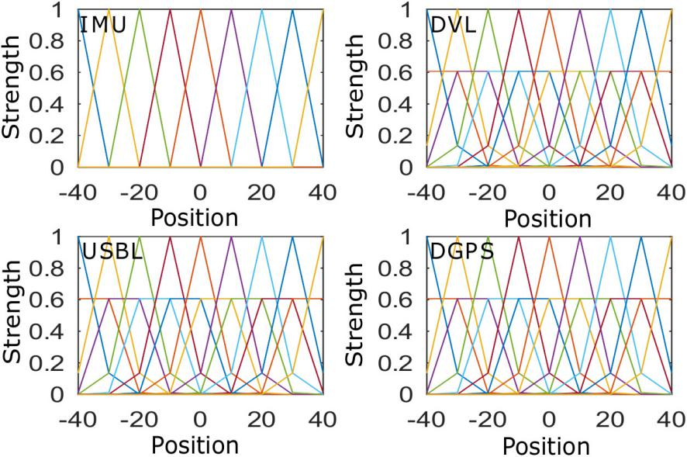

**Figure-3.5: Fusion of two types of sensory inputs**

### 3.2: PC/BC-DIM Neural Network for UW Localization

To localize an underwater robot motion sensors and absolute positioning sensors are used. Each sensory data is first encoded into ……nsors. Amplitude and deviation of each encoded input are the same as weights of respective input.

**3.2.1: Sensors for Simulations**

One-dimensional and same nature of information (e.g., position, heading, etc) is processed from the filter at a time. In the implementation section IMU, DVL, USBL, and DGPS systems are used to estimate the location of AUV. IMU and DVL are dead-reckoning sensors that is why they have to integrate previous states to estimate the current state. USBL and differential Global Positioning System (DGPS) result in an absolute location of an autonomous underwater vehicle.

GPS doesn't work below the surface of the water but has a fine accuracy above the surface of the water. USBL is an alternative of GPS that can work below the surface of the water. A…….hich can be corrected by positioning sensor.

**3.2.2: Encoding of Sensors**

Every sensor has either limitation of reliability or accuracy so that each sensor is encoded with differe…….Range is the distribution of inputs and c is center or mean of respective input. s is the deviation of input and A is amplitude which is set equal to 1.

**Figure-3.6: Encoding of sensory data**

**3.2.3: Decoding of Reconstructed Input**

With the help of the decoding equation, the mean values of reconstructed input are selected. PC/BC-DIM…….ghts, the distribution of output will scatter. The value of reconstructed input also depends on the shape of the weights. If prior information of specific type is available then reconstruction of input will be according to that likelihood.

**3.3: Algorithm of PC/BC-DIM for Underwater Localization**

Generally, there are two types of sensory information available. One is inertial or motion data and second is global fixes information. For global or absolute position estimation, the difference of last position (during the presence of global position) from the current position is fed to the PC/BC-DIM network. Inertial sensors are integrated until global fixes correct the residual error of the dead-reckoning sensor and then these are reinitialized to zero. The algorithm is presented below for an underwater robot localization using PC/BC-DIM neural network. W_i are weights of inertial or motion sensor and W_g are weights of global sensor which are concatenated and stored in W synaptic connection weights. Mval_g is an input of the global sensor and Mval_i is inertial input. Until the last value of the sensor, the filter consistently updates multiple sensory inputs with a single reconstructed response r. Inertial values are accumulated with previous values and global value takes the difference of last value as sensory input. If there is no value present for any sensor then encoded input is assigned with zeros. x is concatenated input and r is reconstruction response. Location is determined by the decoding r response.

In algorithm 3.2 first weights are trained then inertial sensory data is accumulated until the positioning data comes. When any positioning sensor measures location then the current position of the sensor is subtracted from the decoded position. This decoded position is the value of decoded PC/BC-DIM filter on the arrival of the last positioning data. Accumulated inertial measurement resets to zero when a change of position is processed with it from PC/BC-DIM filter. When positional data is not available it is encoded with zeros of the same size.

**Algorithm-3.2: Underwater Robot Localization using PC/BC-DIM Algorithm**

1: W = [W_g W_i]

2: [n , m] = size( W )

3: y = zeros( 1 , n )

4: Mval_g = reference

5: Mval_I = reference

6: tempPos = reference

.

. Deleted…

.

13: **if** val_g is present

14: x_g = Gaussian( val_g - last_g)

15: **else**

16: x_g = ( zeros(1 , m / size ( sensor ) )

17:  **end if**

.

.deleted

.

25: **end if**

26:position = [position tempPos+decoded_Pos]

27:**end while**

# CHAPTER- 4

## RESULTS AND DISCUSSION

In this chapter simulations and experimental results are discussed. As support of the proposed method, some basic trajectories are presented with noisy positions. Using PC/BC-DIM the noise is reduced and a very closer trajectory to the actual noise-free or ground truth trajectory is obtained.

**4.1: Execution of PC/BC-DIM for localization:**

For horizontal coordinate c…….and in the following cases a different type of noise reduction using PC/BC-DIM will be discussed.

**4.1.1: Random Noise Addition:**

First, a circle is made by equation x=cos( t ) and y=sin( t ) where t has 500 values from 0 to 2π. Here, x and y represe…….PC/BC-DIM neural network.

|  |  |  |
| --- | --- | --- |
|  | x_gps = x + noise | (4.1) |
|  | y_gps = x + noise | (4.2) |

Sigma of………nst noise constant 0.2 for GPS points. This shows that with a very high noise still the PC/BC-DIM is producing closer results to the ground noise-free trajectory.

**Figure-4.1: PC/BC-DIM outcome for noisy positioning points**

With the experiment, it is observed that by increasing the number of positioning points the trajectory of the PC/BC-DIM neural network improves.

**Figure-4.2: PC/BC-DIM outcome for 2 times noisy positioning points**

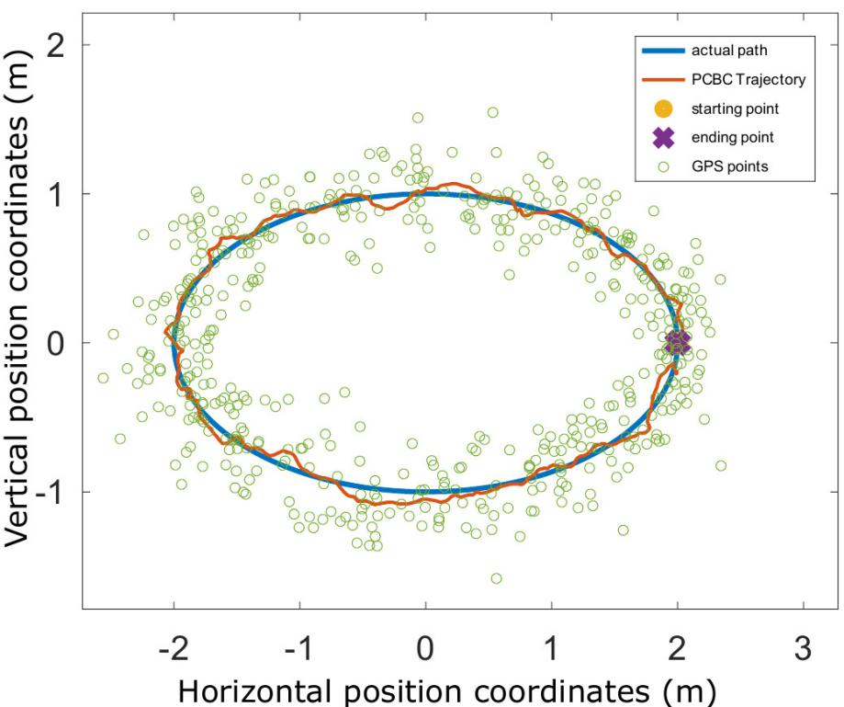

**4.1.2: Non-Gaussian or Abrupt Noise Addition:**

Abrupt noise is the common problem of the ultrashort baseline sensor and it is observed that this noise is ed approach if the change goes beyond the range then it is ignored by the neural network and previous decoded input is used instead of noisy values as GPS is showing in its trajectory.

**Figure-4.3: PC/BC-DIM outcome for non-gaussian or abrupt noise**

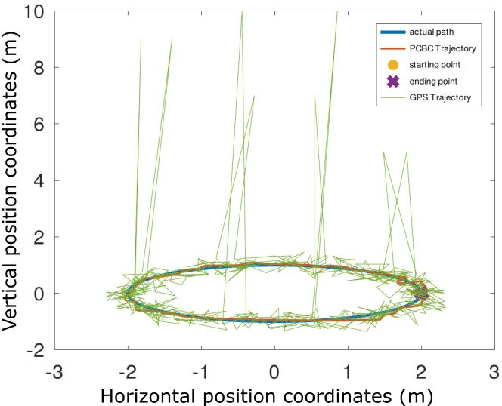

**4.2: Simulation Data Comparison with a B-PR-F Neural Network:**

Behaviour Prediction Reliability Fusion (B-PR-F) proved that it is better than Kalman filter, Extended KalmR-F neural network. Similarly, individual DVL with USBL and DGPS produces better approximation. A detailed comparison is presented in sections below.

**4.2.1: PC/BC-DIM and B-PR-F Comparison:**

The simulations are conducted in an open-source software named as GNU Octave. Before making a compariso…. adding noise to it so integrating the measurements diverge from the original trajectory. Simil…….random noise at all points which has a higher scale in deep water and noise 2 is highly non-gaussian abrupt values at some indexes. DGPS works fine above the surface of the water so for a few seconds similar GT values are selected for DGPS sensory data.

**Figure-4.4: B-PR-F neural network results**

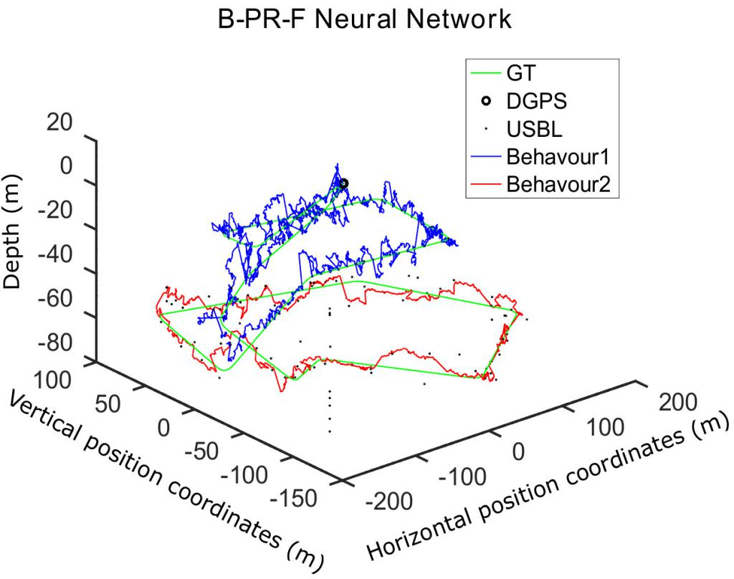

Range of -40 to 40 with the difference of 5 is selected and centers are set using the same configuration. Sigma of DGPS is set equal to step size 5, sigma of USBL is selected 8.5 while both of dead-reckoning method based sensors (DVL and IMU) have 10 of sigma to achieve optimal position estimation. Iterations for PC/BC-DIM are set as 35.

**Figure-4.5: PC/BC-DIM neural network results**

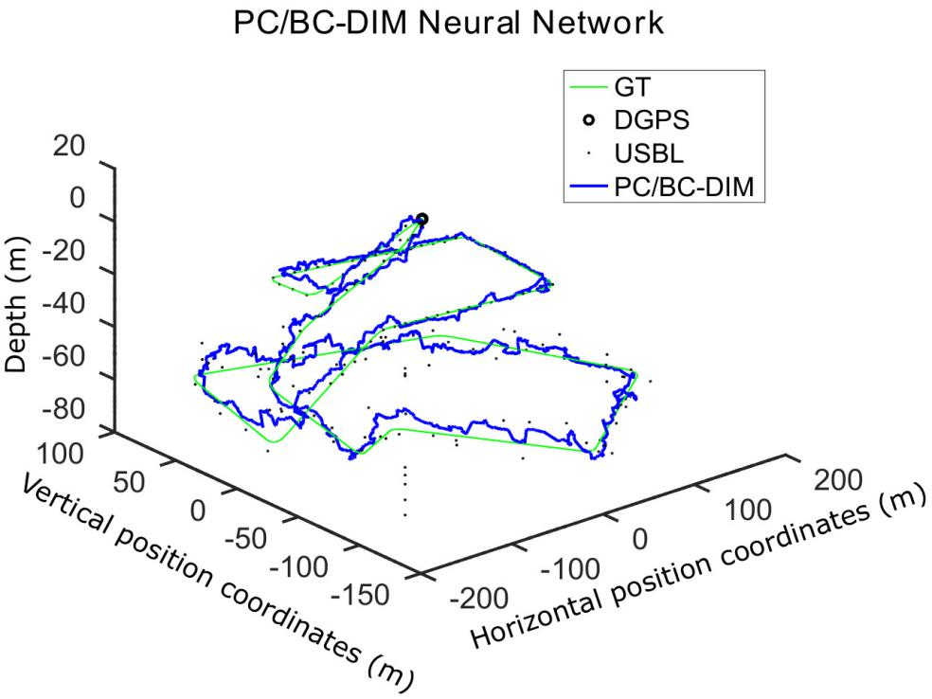

Above figures 4.4 and 4.5 are demonstrating the visual difference between two filters using the same sensory……round truth data.
Statistical comparison gives more clear differences. Table 4.1 shows the differences

|  |  |  |  |  |
| --- | --- | --- | --- | --- |
| Table-4.1: PC/BC-DIM and B-PR-F Simulation Comparison | | | | |
| **Filter** | **Mean Sq Error** | **std Error** | **RMS error** | **Time of execution(s)** |
| B-PR-F | 8 | 788 |  | 2 |
| PC/BC-DIM | 8. | 761 | 3. |  |
|  | | | | |

**Figure-4.6: Error comparison for both neural networks**

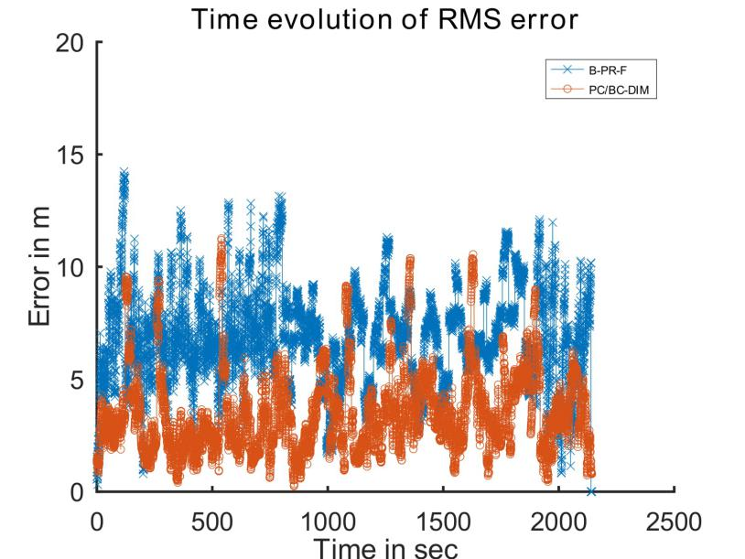

Figure 4.6 is representing the difference between the Root Mean Square (RMS) error of both neural networks. The spikes in PC/BC-DIM can be improved further by increasing the iteration but a minor computation cost will increase..

**Figure-4.7: Depth coordinate of B-PR-F neural network**

For more clear visualization figure 4.7 and figure 4.8 are representing depth coordinate comparison with the GT depth coordinate.

**Figure-4.8: Depth coordinate of PC/BC-DIM neural network**

Figure 4.8 is showing less noisy depth coordinate of the PC/BC-DIM neural network as compared to the B-PR-F neural network. Both neural networks are removing noise of the USBL sensor but PC/BC-DIM is not only eliminating non-gaussian noise but it is also producing smooth and less noisy trajectory as in figure 4.9 presented.

**Figure-4.9: Noisy USBL vs PC/BC-DIM results for vertical coordinate**

|  |  |
| --- | --- |
| *figure4.6* | *figure4.7* |

**4.2.2: All Sensors B-PR-F and without IMU PC/BC-DIM Comparison:**

PC/BC-DIM can give better results without using the IMU sensor and by relying only on the DVL sensor. U….

|  |  |  |  |  |
| --- | --- | --- | --- | --- |
| Table-4.2: PC/BC-DIM and B-PR-F Simulations W**ithout IMU** | | | | |
| **Filter** | **Mean Sq Error** | **std Error** | **RMS error** | **Time of execution(s)** |
| PC/BC-DIM | 146 | 1701 | 341 | 179 |
|  | | | | |

**4.2.3: All Sensors B-PR-F and without DVL PC/BC-DIM Comparison**

PC/BC-DIM can give

GPS and IMU are feed to PC/BC-DIM neural network and it has presented lesser trajectory error as compared to the B-PR-F neural network.

|  |  |  |  |  |
| --- | --- | --- | --- | --- |
| Table-4.3: PC/BC-DIM and B-PR-F Simulations (**without DVL)** | | | | |
| **Filter** | **Mean Sq Error** | **std Error** | **RMS error** | **Time of execution(s)** |
| PC/BC-DIM | 7 | 6 | 4. | 19.979 |
|  | | | | |

**4.3: Experimental Data Comparison with a B-PR-F Neural Network:**

In this experiment, the vehicle traveled for 61 minutes to cover 693 meters of distance. The method is proposed for the estimation of the 2D location of the vehicle on the surface of the water. The location is estimated using low rate absolute positioning data and high rate relative positioning data. In an open environment, DGPS is very accurate above the surface of the water so it is treated as ground truth with its 3662 positions. For the absolute location estimation, 1450 positions of Ultrashort baseline (USBL) are measured and for relative position measurement, 19992 grayscale images of 16 bit are taken by SONAR. SONAR images are converted to useful odometry data to find a change in angle and to get change in images frames.

To process the information from the filter to obtain the optimal position motion vector (Δx , Δy) and positioning vector (x , y) is needed. Detailed information of sensory data is available in appendix B of (Chame et al., 2018) in which for motion estimation scan matching method is used to obtained motion data along the horizontal and vertical coordinates. An angle is needed for motion estimation as the correct motion of Δx and Δy is obtained from the following 4.3 and 4.4 equations. USBL data is used as a positioning sensor.

|  |  |  |
| --- | --- | --- |
|  |  | (4.3) |
|  |  | (4.4) |

Where theta is the current angle or heading of the vehicle. Compass has measured 4357 heading angles. Whennd each angle is wrapped to 2π using octave mapping package.

|  |  |  |
| --- | --- | --- |
|  |  | (4.5) |

|  |  |  |  |  |
| --- | --- | --- | --- | --- |
| Table-4.4: PC/BC-DIM and B-PR-F Experiment | | | | |
| **Filter** | **Mean** | **Std. Dev.** | **Time (sec)** | **Reference** |
| Dead reckoning | 45.7573 | 26.9248 | 12.8949 | Clho, 2018) |
| Kalman Filter | 1.9479 | 3.0804 | 13.5013 |
|  |  |  |  |
|  |  |  |  |
|  |  |  |  |
| **PC/BC-DIM** | **1.3526** | **1.0412** | **45.2462** |  |
|  | | | | |

**Figure-4.10: B-PR-F position estimation**

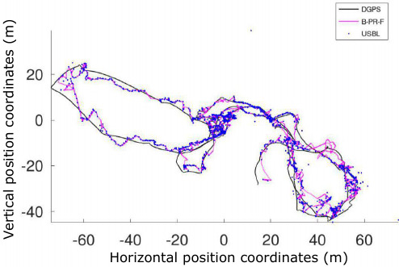

The plotting of experimental results provides a clear difference between the B-PR-F and PC/BC-DIM neural network estimations.

**Figure-4.11: PC/BC-DIM position estimation**

Range of -14 to 14 with a difference of 1 is selected and centers are set using the same configuration. Sigma of USBL is set equal to step size 1 and the sigma of motion estimation vector is selected 3.5 to achieve optimal position. The iterations are set 35 for the PC/BC-DIM neural network.

# CHAPTER- 5

## CONCLUSIONS AND DISCISSION

Water covers more than 70 percent of the earth’s crust and there is a green area for searchers to discover and explore underwater resources. The collection of exploration data is meaningless when the location of an underwater vehicle is not known. GPS and other radio signals do not work below the surface …..Chame proposed the principle of contextual anticipation which resets in the presence of reliable sensory data of USBL and when an unusual measurement of USBL produces then his proposed B-PR-F ignore this unreliable value. Sabra propos…..ture of sensory data and position is estimated. In Experiments, it is observed that more accuracy is achieved as compared to a very recent method using the same sensory data. In future PC/BC-DIM can be used for underwater image recognition, target tracking and simultaneous localization and mapping.

From results, it is cl….. location of an underwater vehicle because of its less computational cost. Limitations of Kalman filter are somewhat overcome by EKF which increases the computational cost and Monte Carlo is the method that can deal with non-linear systems by reducing most of the noise. …….-PR-F overcome the non-Gaussian noise but PC/BC-DIM does not only overcome such noise but it also can deal with highly abrupt position measurements as illustrated in the 3.1 section.

**REFERENCES**

Akyildiz, I. F., Wang, P., & Sun, Z. (2015). Realizing underwater communication through magnetic induction. IEEE Communications Magazine, 53(11), 42–48.

Allotta, B., Caiti, A., Chisci, L., Costanzi, R., Di Corato, F., Fantacci, C., . . . Ridolfi, A. (2016). An unscented kalman filter based navigation algorithm for autonomous underwater vehicles. Mechatronics, 39, 185–195.

Allotta, B., Caiti, A., Costanzi, R., Fanelli, F., Fenucci, D., Meli, E., & Ridolfi, A. (2015). Unscented kalman filtering for autonomous underwater navigation. In Vi international conference on computational methods in marine engineering marine 2015 (pp. 1–10).

Al-Rawi, M., Galdran, A., Elmgren, F., Rodriguez, J., Bastos, J., & Pinto, M. (2017). Landmark detection from sidescan sonar images. In 2017 ieee jordan conference on applied electrical engineering and computing technologies (aeect) (pp. 1–6).

A´ lvarez-Tun˜o´n, O., Rodr´ıguez, A´ ., Jardo´n, A., & Balaguer, C. (2018). Underwater robot navigation for maintenance and inspection of flooded mine shafts. In 2018 ieee/rsj international conference on intelligent robots and systems (iros) (pp. 1482–1487).

Aras, M., Shahrieel, M., Ab Azis, F., & Othman, M. N. (2012). A low cost 4 dof remotely operated underwater vehicle integrated with imu and pressure sensor. In 4th international conference on underwater system technology: Theory and applications 2

Guerrero-Font, E., Massot-Campos, M., Negre, P. L., Bonin-Font, F., & Codina, G. O. (2016, September). An USBL-aided multisensor navigation system for field AUVs. In 2016 IEEE International Conference on Multisensor Fusion and Integration for Intelligent Systems (MFI) (pp. 430-435). IEEE.

Hegrenæs, Ø., Ramstad, A., Pedersen, T., & Velasco, D. (2016). Validation of a new generation dvl for underwater vehicle navigation. In 2016 ieee/oes autonomous underwater vehicles (auv) (pp. 342–348).

Heidemann, J., Stojanovic, M., & Zorzi, M. (2012). Underwater sensor networks: applications, advances and challenges. Philosophical Transactions of the Royal Society A: Mathematical, Physical and Engineering Sciences, 370(1958), 158–175.

Houegnigan, L., Safari, P., Nadeu, C., van der Schaar, M., Sol´e, M., & Andr´e, M. (2017). High performance supervised time-delay estimation using neural networks. In Ieee international conference on acoustics, speech and signal processing. proceedings.

Huang, Y., & Rao, R. P. (2011). Predictive coding. Wiley Interdisciplinary Reviews: Cognitive Science, 2(5), 580–593.

Huang, Y., Zhang, Y., Xu, B., Wu, Z., & Chambers, J. A. (2017). A new adaptive extended kalman filter for cooperative localization. IEEE Transactions on Aerospace and Electronic Systems, 54(1), 353–368.

Johannsson, H., Kaess, M., Englot, B., Hover, F., & Leonard, J. (2010). Imaging sonar-aided navigation for autonomous underwater harbor surveillance. In 2010 ieee/rsj international conference on intelligent robots and systems (pp. 4396–4403).

Karimi, M., Bozorg, M., & Khayatian, A. (2013). A comparison of dvl/ins fusion by ukf and ekf to localize an autonomous underwater vehicle. In 2013 first rsi/ism international conference on robotics and mechatronics (icrom) (pp. 62–67).

Karras, G. C., & Kyriakopoulos, K. J. (2007). Localization of an underwater vehicle using an imu and a laser-based vision system. In 2007 mediterranean conference on control & automation (pp. 1–6).

Ko, N. Y., Kim, T. G., & Noh, S. W. (2011). Monte carlo localization of underwater robot using internal and external information. In 2011 ieee asia-pacific services computing conference (pp. 410–415).

Ko, N. Y., & Kim, T. G. (2012, November). Comparison of Kalman filter and particle filter used for localization of an underwater vehicle. In 2012 9th international conference on ubiquitous robots and ambient intelligence (URAI) (pp. 350-352). IEEE.

Ko, N. Y., Kim, T. G., & Noh, S. W. (2011, December). Monte carlo localization of underwater robot using internal and external information. In 2011 IEEE Asia-Pacific Services Computing Conference (pp. 410-415). IEEE

Ko, N. Y., Noh, S. W., & Choi, H. T. (2014). Simultaneous estimation of sea level and underwater vehicle location. In Oceans 2014-taipei (pp. 1–5).

Ko, N. Y., Kim, T. G., & Choi, H. T. (2016). Synchronous and asynchronous application of a filtering method for underwater robot localization. International Journal of Humanoid Robotics, 13(02), 1550038.

Lawrence, M. W. (1985). Ray theory modeling applied to low-frequency acoustic interaction with horizontally stratified ocean bottoms. The Journal of the Acoustical Society of America, 78(2), 649–658.

Lebastard, V., Chevallereau, C., Amrouche, A., Jawad, B., Girin, A., Boyer, F., & Gossiaux, P. B. (2010). Underwater robot navigation around a sphere using electrolocation sense and kalman filter. In 2010 ieee/rsj international conference on intelligent robots and systems (pp. 4225–4230).

Lee, C.-m., Hong, S.-W., & Seong, W.-J. (2003). An integrated dvl/imu system for precise navigation of an autonomous underwater vehicle. In Oceans 2003. celebrating the past... teaming toward the future (ieee cat. no. 03ch37492) (Vol. 5, pp. 2397–Vol).

Miller, A., Miller, B., & Miller, G. (2018). Auv navigation with seabed acoustic sensing. In 2018 australian & new zealand control conference (anzcc) (pp. 166–171).

Muhammad, N., Toming, G., Tuhtan, J. A., Musall, M., & Kruusmaa, M. (2017). Underwater map-based localization using flow features. Autonomous Robots, 41(2), 417–436.

Petrich, J., Brown, M. F., Pentzer, J. L., & Sustersic, J. P. (2018). Side scan sonar based self-localization for small autonomous underwater vehicles. Ocean Engineering, 161, 221–226.

Ranjan, T., Nherakkol, A., & Navelkar, G. (2010). Navigation of autonomous underwater vehicle using extended kalman filter. In Fira roboworld congress (pp. 1–9).

Ribas, D., Ridao, P., Neira, J., & Tardos, J. D. (2006). Slam using an imaging sonar for partially structured underwater environments. In 2006 ieee/rsj international conference on intelligent robots and systems (pp. 5040–5045).

Sabra, A., & Fung, W.-k. (2017). Dynamic localization plan for underwater mobile sensor nodes using fuzzy decision support system. In Oceans 2017-anchorage (pp. 1–8).

Shao, X., He, B., Guo, J., & Yan, T. (2016). The application of auv navigation based on adaptive extended kalman filter. In Oceans 2016-shanghai (pp. 1–4).

Wan, E. A., & Van Der Merwe, R. (2000). The unscented kalman filter for nonlinear estimation. In Proceedings of the ieee 2000 adaptive systems for signal processing, communications, and control symposium (cat. no. 00ex373) (pp. 153–158).

Xie, Y. X., Liu, J., Hu, C. Q., Cui, J. H., & Xu, H. (2016, October). AUV dead-reckoning navigation based on neural network using a single accelerometer. In Proceedings of the 11th ACM International Conference on Underwater Networks & Systems (pp. 1-5).

**APPENDIX-01**

|  |  |  |
| --- | --- | --- |
| **Abbreviations Used in the Thesis** | | |
| **S #** | **Items** | **Abbreviations** |
| **1** | Inertial Measurement Unit | IMU |
| **2** | Doppler Velocity Log | DVL |
| **3** | Differential Global Positioning System | DGPS |
| **4** | Ultrashort Baseline | USBL |
| **5** | Long Baseline | LBL |
| **6** | Short Baseline | SBL |
| **7** | Autonomous Underwater Vehicle | AUV |
| **8** | Rometly Operated vehicle | ROV |
| **9** | Degree of Frame | DOF |
| **10** | Time of Arrival | TOA |
| **11** | Strapdown Inertial Navigation System | SINS |
| **12** | Extended Kalman Filter | EKF |
| **13** | Unscented Kalman Filter | UKF |
| **14** | Partical Filter | PF |
| **15** | Simultaneous Localization and Mapping | SLAM |
| **16** | Monte Carlo Localization | MCL |
| **17** | Predictive Coding / Biased Competition | PC/BC |
| **18** | Divisive Input Modulation | DIM |
| **19** | Behaviour - Prediction Reliability - Fusion | B-PR-F |
| **20** | Neural Network | NN |
| **21** | Receptive Fields | RF |
| **22** | Probability Density Function | PDF |
| **23** | Weights | W |
| **24** | Wireless Fidelity | Wi-Fi |
| **25** | Sound Navigation and Ranging | SONAR |
| **26** | Standard | std |
| **27** | Root Mean Square | RMS |
|  |  |  |

**APPENDIX-02**

|  |  |  |  |  |
| --- | --- | --- | --- | --- |
| ***Turnitin* Originality Report** | | | | |
| Tested on June 2, 2020 by Turnitin Anti Plagiarism Software Provided by Higher Education Commission, Pakistan to the Instructors of the University of Gujrat, Punjab, Pakistan. | | | | |
| Thesis Title: Multisensory Fusion for Underwater Robot Localization and Exploration  Authors’ Name: Umair Ali  Institution: University Of Gujrat Hafiz Hayat Campus | | | | |
| **PRIMARY SOURCES** | | | | |
| **SIMILARITY INDEX** | **INTERNET SOURCES** | **PUBLICATIONS** | **STUDENT PAPERS** | |
| **5%** | **01%** | **03%** | **2%** | |
| **Internet Source** | | | | **01%** |
| 1. http://linknovate.com(Internet Source) | | | |
| 1. http://www.infona.pl(Internet Source) | | | |
|  | | | |
|  | | | |
|  | | | |
|  | | | |
|  | | | |
| 1. http://www.nature.com(Internet Source) | | | |
| 1. http://eprints.usq.edu.au(Internet Source) | | | |
| **Publications** | | | | **03%** |
| 1. M. W. Spratling. "A neural implementation of Bayesian inference based on predictive coding" , Connection Science, 2016 (Publication) | | | |
| 1. Nak Yong Ko, Tae Gyun Kim, Sung Woo Noh. "Monte Carlo Localization of Underwater Robot Using Internal and External Information" , 2011 IEEE Asia-Pacific Services Computing Conference, 2011 (Publication) | | | |
| 1. Jiawei Zhang, Wei Wang, Guangming Xie, Hong Shi. "Camera-IMU-based underwater localization" , Proceedings of the 33rd Chinese Control Conference, 2014 (Publication) | | | |
|  | | | |
|  | | | |
|  | | | |
| 1. Hendry Ferreira Chame, Matheus Machado dos Santos, Silvia Silva da Costa Botelho. "Neural network for black-box fusion of underwater robot localization under unmodeled noise" , Robotics and Autonomous Systems, 2018 (Publication) | | | |
| **Student Paper** | | | | **02%** |
| 1. Submitted to Higher Education Commission Pakistan (Student Paper) | | | |
| 1. Submitted to King's College (Student Paper) | | | |
| 1. Submitted to University of Southampton (Student Paper) | | | |
| 1. Submitted to University of Central England in Birmingham (Student Paper) | | | |
| 1. Submitted to Nanyang Technological University (Student Paper) | | | |
| 1. Submitted to Cranfield University (Student Paper) | | | |
| 1. Submitted to University of Sheffield (Student Paper) | | | |
| 1. Submitted to National University of Singapore (Student Paper) | | | |
| 1. Submitted to Heriot-Watt University (Student Paper) | | | |
| 1. Submitted to University of Canterbury (Student Paper) | | | |